**MENTAL HEALTH APP**

**An Engineering Project in Community Service**

**Phase – II Report**

***Submitted by***

**Siddharth Raj** (19BCY10099)

***in partial fulfillment of the requirements for the degree of***

***Bachelor of Engineering and Technology***



**VIT Bhopal University**

**Bhopal**

**Madhya Pradhesh**

**April 2022**



**Bonafide Certificate**

Certified that this project report titled **“Mental Health App”** is the bonafide work of “**Amman Agrawal** (19BCG10057), **Aryan** (19BCE10126), **Shruti Jha** (19MIM10034), **Prateek Verma** (19BCE10358), **Akshat Sharma** (19BCE10147), **Aniket Bandyopadhyay** (19MIM100115), **Arya Dubey** (19MIM10029), **Siddharth Raj** (19BCY10099)**”** who carried out the project work under my supervision.

This project report (Phase II) is submitted for the Project Viva-Voce examination held on 21 April 2022.

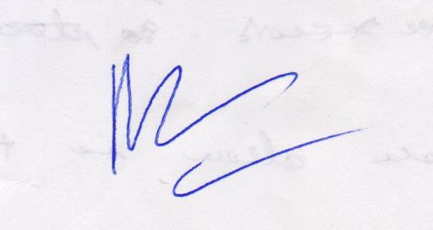

**Supervisor**

**Comments & Signature ( Reviewer 1)**

**Comments & Signature ( Reviewer 2)**

|  |  |  |
| --- | --- | --- |
| **CHAPTER NO.** | **TITLE** | **PAGE NO.** |
| 1 | **INTRODUCTION** | **3-5** |
| 2 | **EXISTING WORK/LITERATURE SURVEY** | **5-7** |
| 3 | **Individual Contribution** | **7-33** |
| 4 | **CONCLUSION** | **33** |
| 5 | **REFERENCE** | **34** |

1. **INTRODUCTION**
   1. **Motivation**

Our motivation behind this project was to provide a platform for many affected by concerns related to mental illness and other safety features which have been more demanding in recent times due to the covid-19 pandemic. The app will provide a new platform for many who are unable to access such services as well as the resources which are provided should be useful.

Our main objective was accessibility and resourcefulness in the making and motive behind our work in this sector. Our work highlights these traits and implements the features which are critical to those affected by mental illness regardless of their location. Another one of the motives was the issue be addressed no matter how minor or major its effect on the masses or individual.

* 1. **Objective**

People all around the world suffer from depression, behavioral disorders, and mental illnesses. Many can’t afford traditional therapy, worry about the stigma of in-office treatment, or don’t have access to treatment for various reasons.

On the other hand, many mentally healthy people want to find an internal balance and live more fulfilling lives but aren’t interested in traditional therapy.

The coronavirus pandemic has revealed deep cracks in the healthcare system of entire world. People across all demographics in the world are feeling isolated, lonely, and anxious.

A spike of downloads of mental health apps has been observed since the beginning of the coronavirus pandemic. Mental Health (mHealth) apps can be an alternative to traditional therapy as they’re lighter on the wallet, available to all smartphone users, and ensure privacy.

Among adults aged 18 or older in the U.S., the prevalence of mental illnesses has increased from 17.7% (39.8mil Americans) in 2008 to 20.6% (51.5mil) in 2019. Of this population, 26.0% (13.3mil) perceived having an unmet need for mental health services. The most common reason for unmet needs is affordability, with other barriers including mental health stigma, and provider shortages or wait time.

Currently there are various popular mental health apps like Talkspace, Calm, BetterHelp but these apps have problems such as some of them are not appropriate for people in certain age group, or those apps don’t have the required features.

The Objective behind our app is to give a readily available mental health solution to everyone who uses a smartphone. As the need for such an app has increased after this pandemic. This app has some features which we have focused on that makes it better than currently available apps like: -

Habit Tracker

Mood Tracker

Self-Assessment Quizzes

Breathing Exercises

1. **LITERATURE REVIEW**

**Existing Work with Limitations**

* The current system of maintenance of most of the mental health tracker is manual . This system is difficult to handle due to following drawbacks :
* The current system of maintenance of most of the mental health tracker is manual . This system is difficult to handle due to following drawbacks :

The current system of maintenance of most of the mental health tracker is manual This system is difficult to handle due to following drawbacks:

1.Effectiveness: The biggest concern with technological interventions is obtaining scientific evidence that they work and that they work as well as traditional methods.

2.For whom and for what: Another concern is understanding if apps work for all people and for all mental health conditions.

3.Privacy: Apps deal with very sensitive personal information so app makers need to be able to guarantee privacy for app users.

4.Guidance: There are no industry-wide standards to help consumers know if an app or other mobile technology is proven effective.

5.Regulation: The question of who will or should regulate mental health technology and the data it generates needs to be answered.

6.Overselling: There is some concern that if an app or program promises more than it delivers, consumers may turn away from other, more effective therapies.

**Problem Solution**

The main purpose is to help each individual be better able to cope with their mental health in various forms which they are otherwise unable to do so without outside help.

The entire activity is to help them through with proper guidance at each level determined by the app. These could include:

Therapy needed to understand the individual.

Symptom tracking to better understand the problem.

Suggestions to better tackle the scenario at hand.

Adaptable based on your goals.

Ability to track daily progress.

Visual Insights with actionable exercises.

Daily Reminder to keep you on track.

Customizable based on your needs and goals.

“Shape Matching and Object Recognition Using Shape Contexts”, proposed shape detection method using a feature called shape context. Shape context describes all boundary points of a shape with respect to any single boundary point. Shape recognition can be achieved by matching this feature with a prior knowledge of the shape context of the boundary points of the object.

1. **Individual Contribution**
2. **Navigation list and Home:**
3. You are able to navigate through the various modules/features of the app by clicking the three bars icon on the top left of the screen. By clicking this, the navigation menu pops up, allowing you to navigate to the feature you like.
4. On the Home screen of MentAlly, a daily motivational quote is shown in order to stimulate and encourage the user. If you wish to change the wallpaper displayed on the home screen, you can do so from the Change Wallpaper module. MentAlly provides various aesthetically pleasing wallpapers to comfort you and complement your style.

**Architecture:**

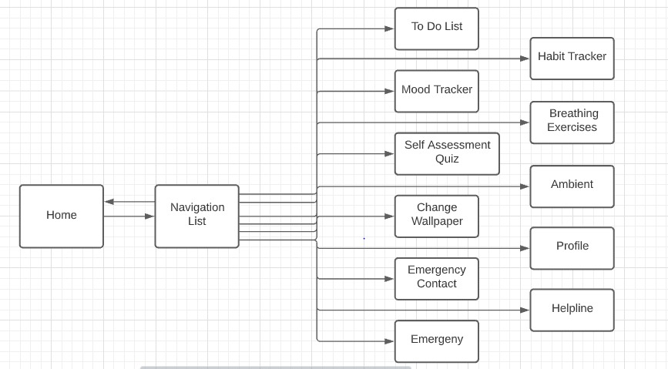

**Code and Outcome:**

1. *XML Code:*
2. *For Home:*

<?xml version="1.0" encoding="utf-8"?>  
<RelativeLayout xmlns:android="http://schemas.android.com/apk/res/android"  
 android:layout_width="wrap_content"  
 android:layout_height="wrap_content"  
 xmlns:app="http://schemas.android.com/apk/res-auto"  
 xmlns:tools="http://schemas.android.com/tools"  
 android:layout_margin="1dp"  
 tools:context=".ui.home.HomeActivity">  
  
 <pl.droidsonroids.gif.GifImageView  
 android:layout_width="match_parent"  
 android:layout_height="match_parent"  
 android:id="@+id/gif"  
 android:adjustViewBounds="true"  
 android:scaleType="centerCrop"  
 android:src="@drawable/waterfall2"  
 android:background="@color/black"/>  
  
 <TextView  
 android:id="@+id/motivational_quote"  
 android:layout_width="wrap_content"  
 android:layout_height="wrap_content"  
 android:layout_centerHorizontal="true"  
 android:layout_marginTop="50dp"  
 android:gravity="center"  
 android:textColor="#FFFFFF"  
 android:textSize="40sp"  
 app:layout_constraintEnd_toEndOf="parent"  
 app:layout_constraintStart_toStartOf="parent"  
 app:layout_constraintTop_toTopOf="parent" />  
  
</RelativeLayout>

1. For Navigation List

<?xml version="1.0" encoding="utf-8"?>  
<LinearLayout xmlns:android="http://schemas.android.com/apk/res/android"  
 android:orientation="vertical" android:layout_width="match_parent"  
 android:layout_height="40pt"  
 android:background="@color/colorPrimary"  
 android:layout_gravity="bottom"  
 android:padding="16dp"  
 android:theme="@style/ThemeOverlay.AppCompat.Dark">  
  
</LinearLayout>

1. Java Code:
2. For Home

package com.pacman.MentAlly.ui.home;

import android.animation.ObjectAnimator;

import android.content.Intent;

import android.graphics.drawable.AnimationDrawable;

import android.os.Bundle;

import android.view.View;

import android.widget.Button;

import android.widget.FrameLayout;

import android.widget.ImageView;

import android.view.animation.Animation;

import android.view.animation.AnimationUtils;

import android.widget.FrameLayout;

import android.widget.TextView;

import androidx.annotation.ColorInt;

import androidx.annotation.Nullable;

import androidx.appcompat.widget.AppCompatImageView;

import com.pacman.MentAlly.R;

import com.pacman.MentAlly.ui.menu.WallpaperFragment;

import java.util.Random;

import pl.droidsonroids.gif.GifImageView;

public class HomeActivity extends MainActivity {

    private int theme;

    Button d;

    private TextView quote;

    private QuotesModel mQuotes = new QuotesModel();

    @Override

    protected void onCreate(@Nullable Bundle savedInstanceState) {

        super.onCreate(savedInstanceState);

        final FrameLayout contentFrameLayout = findViewById(R.id.frag_container);

        d = findViewById(R.id.def);

        WallpaperFragment w = new WallpaperFragment();

        this.theme = w.theme;

        getLayoutInflater().inflate(R.layout.wallpaperlayout, contentFrameLayout);

        quoteAnimation();

        if (this.theme != -1) {

            getLayoutInflater().inflate(R.layout.wallpaperlayout, contentFrameLayout);

            AppCompatImageView view = findViewById(R.id.imageView);

            view.setImageResource(this.theme);

        }

        else{

            getLayoutInflater().inflate(R.layout.defaultwallpaperlayout, contentFrameLayout);

        }

    }

    public void quoteAnimation(){

        quote = (TextView) findViewById(R.id.motivational_quote);

        setQuote();

        Animation aniFade = AnimationUtils.loadAnimation(getApplicationContext(),R.anim.fade_in);

        quote.startAnimation(aniFade);

    }

    public void setQuote(){

        Random num = new Random();

        int quoteNum = num.nextInt(mQuotes.getLength());

        quote.setText(mQuotes.getQuote(quoteNum));

    }

}

package com.pacman.MentAlly.ui.home;

import android.content.Intent;

import android.database.Cursor;

import android.graphics.Bitmap;

import android.graphics.BitmapFactory;

import android.graphics.drawable.BitmapDrawable;

import android.graphics.drawable.Drawable;

import android.net.Uri;

import android.os.Bundle;

import android.provider.MediaStore;

import android.util.Log;

import android.view.MenuItem;

import android.widget.ImageView;

import android.widget.Toast;

import androidx.annotation.NonNull;

import androidx.annotation.Nullable;

import androidx.appcompat.app.ActionBarDrawerToggle;

import androidx.appcompat.app.AppCompatActivity;

import androidx.appcompat.widget.Toolbar;

import androidx.core.view.GravityCompat;

import androidx.drawerlayout.widget.DrawerLayout;

import androidx.fragment.app.DialogFragment;

import com.google.android.material.navigation.NavigationView;

import com.pacman.MentAlly.R;

import com.pacman.MentAlly.ui.Mood.MoodActivity;

import com.pacman.MentAlly.ui.ToDoList.ToDoListActivity;

import com.pacman.MentAlly.ui.ambient.AmbientActivity;

import com.pacman.MentAlly.ui.breathing.BreathingActivity;

import com.pacman.MentAlly.ui.emergency.EmergencyContactsActivity;

import com.pacman.MentAlly.ui.emergency.EmergencyDialogFragment;

import com.pacman.MentAlly.ui.habit.HabitTrackerActivity;

import com.pacman.MentAlly.ui.profile.ProfileActivity;

import com.pacman.MentAlly.ui.quiz.QuizActivity;

import com.pacman.MentAlly.ui.menu.WallpaperFragment;

import com.pacman.MentAlly.ui.helpline.helplineActivity;

public class MainActivity extends AppCompatActivity implements NavigationView.OnNavigationItemSelectedListener {

    private static final int SELECTED_PIC = 1;

    protected DrawerLayout draw;

    ImageView imageView;

    @Override

    protected void onCreate(@Nullable Bundle savedInstanceState) {

        super.onCreate(savedInstanceState);

        setContentView(R.layout.activity_main);

        imageView = findViewById(R.id.imageView);

        Toolbar toolbar = findViewById(R.id.toolbar);

        setSupportActionBar(toolbar);

        draw = findViewById(R.id.drawer_layout);

        NavigationView navView = findViewById(R.id.nav_view);

        navView.setNavigationItemSelectedListener(this);

        //implement navigation bar icon

        ActionBarDrawerToggle toggle = new ActionBarDrawerToggle(this, draw, toolbar, R.string.navigation_drawer_open,

                R.string.navigation_drawer_close);

        draw.addDrawerListener(toggle);

        toggle.syncState();

    }

    @Override

    public boolean onNavigationItemSelected(@NonNull MenuItem item) {

        switch(item.getItemId()){

            case R.id.nav_home:

                Intent i_home = new Intent(this, HomeActivity.class);

                startActivity(i_home);

                draw.closeDrawer(GravityCompat.START);

                break;

            case R.id.nav_profile:

                Log.d("Hi", "hello");

                Intent i_profile = new Intent(this, ProfileActivity.class);

                startActivity(i_profile);

                draw.closeDrawer(GravityCompat.START);

                Log.d("Hi", "hello");

                break;

            case R.id.nav_habit:

                Intent i_habit = new Intent(this, HabitTrackerActivity.class);

                startActivity(i_habit);

                draw.closeDrawer(GravityCompat.START);

                break;

            case R.id.nav_todo:

                Intent i_todo = new Intent(this, ToDoListActivity.class);

                startActivity(i_todo);

                draw.closeDrawer(GravityCompat.START);

                break;

            case R.id.nav_mood:

                Intent i_mood = new Intent(this, MoodActivity.class);

                startActivity(i_mood);

                draw.closeDrawer(GravityCompat.START);

                break;

            case R.id.nav_breathe:

                Intent i_breathe = new Intent(this, BreathingActivity.class);

                startActivity(i_breathe);

                draw.closeDrawer(GravityCompat.START);

                break;

            case R.id.nav_quiz:

                Intent i_quiz = new Intent(this, QuizActivity.class);

                startActivity(i_quiz);

                draw.closeDrawer(GravityCompat.START);

                break;

            case R.id.nav_ambient:

                Intent i_ambient = new Intent(this, AmbientActivity.class);

                startActivity(i_ambient);

                draw.closeDrawer(GravityCompat.START);

                break;

            case R.id.nav_wallpaper:

                getSupportFragmentManager().beginTransaction().replace(R.id.frag_container, new WallpaperFragment()).commit();

                draw.closeDrawer(GravityCompat.START);

                break;

            case R.id.nav_contacts:

                Intent i_contacts = new Intent(this, EmergencyContactsActivity.class);

                startActivity(i_contacts);

                draw.closeDrawer(GravityCompat.START);

                break;

            case R.id.nav_helpline:

                Intent i_help = new Intent(this, helplineActivity .class);

                startActivity(i_help);

                draw.closeDrawer(GravityCompat.START);

                break;

            case R.id.nav_emergency:

                DialogFragment emergencyDialog = new EmergencyDialogFragment();

                emergencyDialog.show(getSupportFragmentManager(), "emergency");

                draw.closeDrawer(GravityCompat.START);

                break;

        }

        return true;

    }

    @Override

    public void onActivityResult(int requestCode, int result, Intent data){

        super.onActivityResult(requestCode,result,data);

        switch(requestCode){

            case SELECTED_PIC:

                if(requestCode == RESULT_OK){

                    Uri uri = data.getData();

                    String[] projection = {MediaStore.Images.Media.DATA};

                    Cursor cursor = getContentResolver().query(uri,projection,null,null,null );

                    cursor.moveToFirst();

                    int columnindex = cursor.getColumnIndex(projection[0]);

                    String filepath = cursor.getString(columnindex);

                    cursor.close();

                    Bitmap b = BitmapFactory.decodeFile(filepath);

                    Drawable d = new BitmapDrawable(b);

                    imageView.setBackground(d);

                }

        }

    }

    @Override

    public void onBackPressed() {

        //close navigation bar before closing app

        if(draw.isDrawerOpen(GravityCompat.START)){

            draw.closeDrawer(GravityCompat.START);

        }

        else {

            super.onBackPressed();

        }

    }

}

package com.pacman.MentAlly.ui.home;

public class QuotesModel {

    public String[] mQuotes = {

            "One thing at a time ☺",

            "You are amazing! \uD83D\uDE0D",

            "You are not alone ♥",

            "Fall seven times and stand up eight \uD83D\uDCAA",

            "Believe you can and you're halfway there \uD83D\uDE0A",

            "Love yourself ♥",

            "Stay strong, stay positive and never give up \uD83D\uDCAA",

            "You miss 100% of the shots you don't take.",

            "We all have to start somewhere.",

            "Victory is always possible for the person who refuses to stop fighting.",

            "Breathe. Take care. Stand still for a minute. What you are looking for might just be looking for you too.",

            "Wherever you are, be all there.",

            "Never dull your shine for somebody else.",

            "In any given moment we have two options: to step forward into growth or back into safety.",

            "Today, you have 100% of your life left.",

            "Forget all the reasons why it won't work and believe the one reason why it will.",

            "The master has failed more times than the beginner has even tried.",

            "Going back isn't an option. Standing still is not enough.",

            "Look for something positive in each day, even if some days you have to look a little harder.",

            "Be strong because thing will get better. It may be stormy now, but it never rains forever.",

            "When you can't find sunshine, be the sunshine.",

            "Every day is a new beginning. Take a deep breath, smile and start again",

            "If you never try, you will never know.",

            "Don't Quit.",

            "Don't give up. Great things take time.",

            "You are wonderful as you are.",

            "If you stumble, you are still moving forward."

    };

    public String getQuote(int i) {

        String quote = mQuotes[i];

        return quote;

    }

    public int getLength(){

        int len = mQuotes.length;

        return len;

    }

}

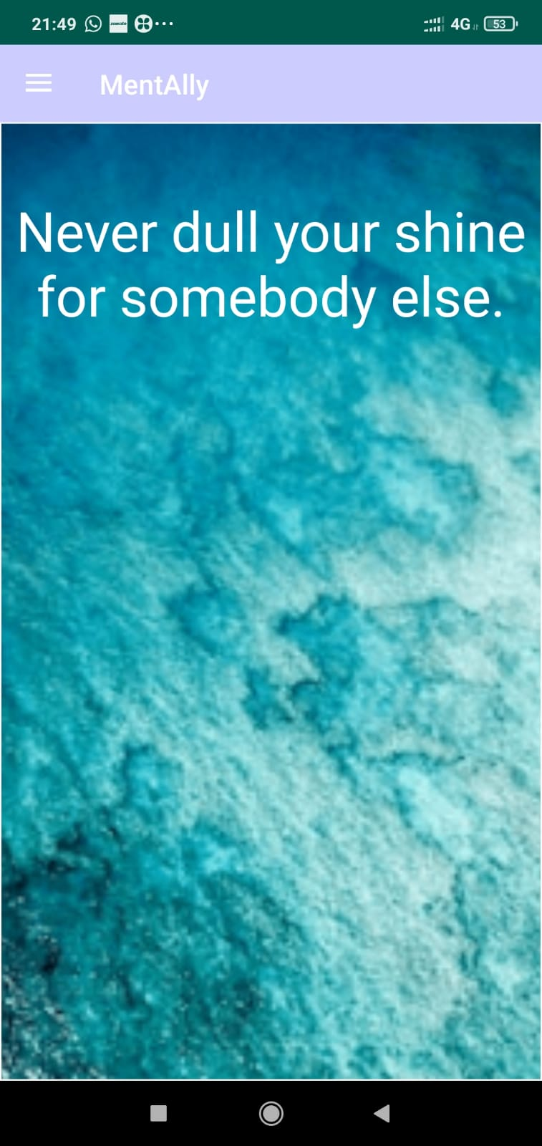

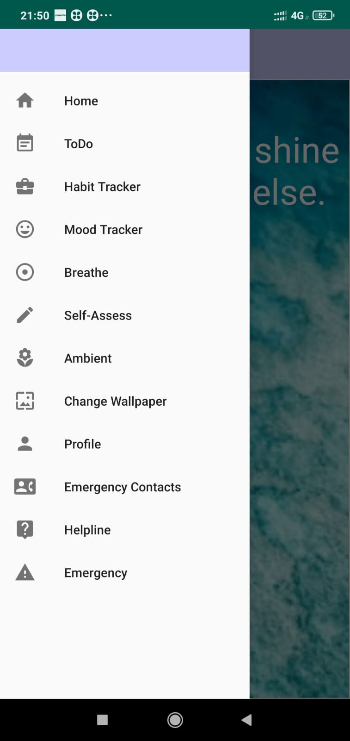

1. **Emergency Contacts and Helpline:**
2. In the case that the user is in a state of stress and/or panic, there are several quick-to-access helplines given to the user. The user has an option to visit their website or call a particular helpline for a more private conversation.
3. We understand that in times of stress, family helps us out the most. That is why Mentally has provided an emergency contacts module where users can enter family members’ contacts and contact them in an emergency.
4. Last but not least, mentally has a Call Emergency Services feature where the user is able to call 911 if something has gone wrong, or they are in need of help urgently.

**Architecture:**

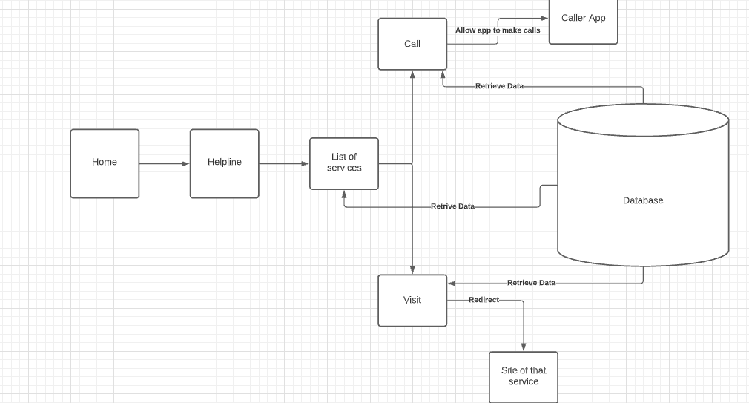

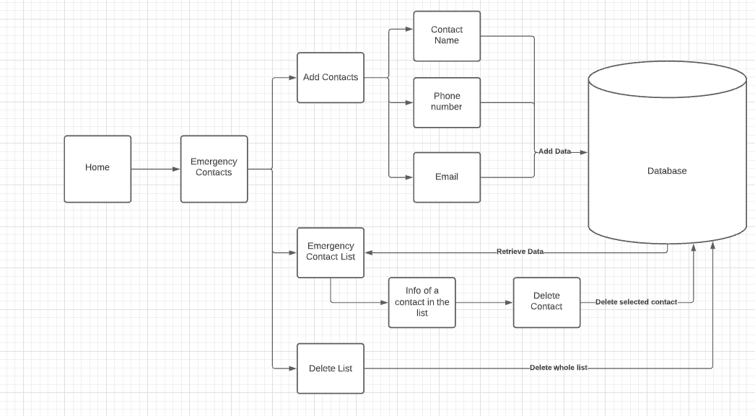

**Code and Outcome:**

1. XML Code:
2. For Helpline:

<RelativeLayout xmlns:android="http://schemas.android.com/apk/res/android"  
 xmlns:app="http://schemas.android.com/apk/res-auto"  
 xmlns:tools="http://schemas.android.com/tools"  
 android:layout_width="match_parent"  
 android:layout_height="match_parent"  
 android:layout_gravity="center_horizontal"  
 android:layout_centerHorizontal="true"  
 android:orientation="vertical" >  
 tools:context=".ui.helpline.helplineActivity">  
  
 <ScrollView  
 android:layout_width="match_parent"  
 android:layout_centerHorizontal="true"  
 android:layout_height="match_parent">  
  
 <HorizontalScrollView  
 android:layout_width="match_parent"  
 android:layout_gravity="center_horizontal"  
 android:layout_height="match_parent">  
  
 <TableLayout  
 android:layout_width="match_parent"  
 android:layout_height="match_parent"  
 android:layout_centerHorizontal="true"  
 android:layout_marginStart="0dp"  
 android:layout_marginTop="0dp">  
  
 <ImageView  
 android:id="@+id/imageView2"  
 android:layout_width="match_parent"  
 android:layout_height="60dp"  
 android:layout_gravity="center_horizontal"  
 android:clickable="false"  
 app:srcCompat="@drawable/app_logo2" />  
  
 <TextView  
 android:id="@+id/title3"  
 android:layout_width="match_parent"  
 android:layout_height="wrap_content"  
 android:fontFamily="@font/arima_madurai_extrabold"  
 android:textStyle="bold"  
 android:paddingVertical="20sp"  
 android:text="Helpline"  
 android:textAlignment="center"  
 android:textColor="#1A237E"  
 android:textSize="25sp" />  
  
 <TableRow  
 android:layout_width="match_parent"  
 android:layout_gravity="center_horizontal"  
 android:layout_marginHorizontal="@dimen/activity_horizontal_margin"  
 android:layout_height="wrap_content">  
  
 <TableRow  
 android:layout_width="match_parent"  
 android:layout_gravity="center_horizontal"  
 android:layout_height="wrap_content">  
  
 <TextView  
 android:id="@+id/kidsHelp"  
 android:layout_width="wrap_content"  
 android:layout_height="wrap_content"  
 android:layout_marginTop="0dp"  
 android:text="Kids Help Phone" />  
  
 <Button  
 android:id="@+id/kidsHelpCall"  
 android:layout_width="wrap_content"  
 android:layout_height="wrap_content"  
 android:layout_marginStart="100dp"  
 android:layout_marginTop="0dp"  
 android:text="Call" />  
  
 <Button  
 android:id="@+id/kidsHelpVisit"  
 android:layout_width="wrap_content"  
 android:layout_height="wrap_content"  
 android:layout_marginStart="0dp"  
 android:layout_marginTop="0dp"  
 android:text="Visit" />  
  
 </TableRow>  
  
 </TableRow>  
  
  
 <TableRow  
 android:layout_width="match_parent"  
 android:layout_gravity="center_horizontal"  
 android:layout_marginHorizontal="@dimen/activity_horizontal_margin"  
 android:layout_height="wrap_content">  
  
 <TableRow  
 android:layout_width="match_parent"  
 android:layout_gravity="center_horizontal"  
 android:layout_height="wrap_content">  
  
 <TextView  
 android:id="@+id/safeHaven"  
 android:layout_width="wrap_content"  
 android:layout_height="wrap_content"  
 android:layout_marginTop="0dp"  
 android:text="Safe Haven Women Shelter" />  
  
 <Button  
 android:id="@+id/safeHavenCall"  
 android:layout_width="wrap_content"  
 android:layout_height="wrap_content"  
 android:layout_marginStart="32dp"  
 android:layout_marginTop="0dp"  
 android:text="Call" />  
  
 <Button  
 android:id="@+id/safeHavenVisit"  
 android:layout_width="wrap_content"  
 android:layout_height="wrap_content"  
 android:layout_marginStart="0dp"  
 android:layout_marginTop="0dp"  
 android:text="Visit" />  
  
 </TableRow>  
  
 </TableRow>  
  
  
 <TableRow  
  
 android:layout_width="match_parent"  
 android:layout_gravity="center_horizontal"  
 android:layout_marginHorizontal="@dimen/activity_horizontal_margin"  
 android:layout_height="wrap_content">  
  
 <TableRow  
 android:layout_width="match_parent"  
 android:layout_gravity="center_horizontal"  
 android:layout_height="wrap_content">  
  
 <TextView  
 android:id="@+id/transLifeline"  
 android:layout_width="wrap_content"  
 android:layout_height="wrap_content"  
 android:layout_marginTop="0dp"  
 android:text="Trans Lifeline" />  
  
 <Button  
 android:id="@+id/transLifelineCall"  
 android:layout_width="wrap_content"  
 android:layout_height="wrap_content"  
 android:layout_marginStart="120dp"  
 android:layout_marginTop="0dp"  
 android:text="Call" />  
  
 <Button  
 android:id="@+id/transLifelineVisit"  
 android:layout_width="wrap_content"  
 android:layout_height="wrap_content"  
 android:layout_marginStart="0dp"  
 android:layout_marginTop="0dp"  
 android:text="Visit" />  
  
 </TableRow>  
  
 </TableRow>  
  
 <TableRow  
 android:layout_width="match_parent"  
 android:layout_gravity="center_horizontal"  
 android:layout_marginHorizontal="@dimen/activity_horizontal_margin"  
  
 android:layout_height="wrap_content">  
  
 <TableRow  
 android:layout_width="match_parent"  
 android:layout_gravity="center_horizontal"  
 android:layout_height="wrap_content">  
  
 <TextView  
 android:id="@+id/chimoHelp"  
 android:layout_width="wrap_content"  
 android:layout_height="wrap_content"  
 android:layout_marginTop="0dp"  
 android:text="Chimo Helpline" />  
  
 <Button  
 android:id="@+id/chimoHelpCall"  
 android:layout_width="wrap_content"  
 android:layout_height="wrap_content"  
 android:layout_marginStart="110dp"  
 android:layout_marginTop="0dp"  
 android:text="Call" />  
  
 <Button  
 android:id="@+id/chimoHelpVisit"  
 android:layout_width="wrap_content"  
 android:layout_height="wrap_content"  
 android:layout_marginStart="0dp"  
 android:layout_marginTop="0dp"  
 android:text="Visit" />  
  
 </TableRow>  
  
 </TableRow>  
  
  
 <TableRow  
 android:layout_width="match_parent"  
 android:layout_gravity="center_horizontal"  
 android:layout_marginHorizontal="@dimen/activity_horizontal_margin"  
 android:layout_height="wrap_content">  
  
 <TableRow  
 android:layout_width="match_parent"  
 android:layout_gravity="center_horizontal"  
 android:layout_height="wrap_content">  
  
 <TextView  
 android:id="@+id/someOther"  
 android:layout_width="wrap_content"  
 android:layout_height="wrap_content"  
 android:layout_marginTop="0dp"  
 android:text="Some Other Solutions" />  
  
 <Button  
 android:id="@+id/someOtherCall"  
 android:layout_width="wrap_content"  
 android:layout_height="wrap_content"  
 android:layout_marginStart="68dp"  
 android:layout_marginTop="0dp"  
 android:text="Call" />  
  
 <Button  
 android:id="@+id/someOtherVisit"  
 android:layout_width="wrap_content"  
 android:layout_height="wrap_content"  
 android:layout_marginStart="0dp"  
 android:layout_marginTop="0dp"  
 android:text="Visit" />  
  
 </TableRow>  
  
 </TableRow>  
  
  
 <TableRow  
 android:layout_width="match_parent"  
 android:layout_gravity="center_horizontal"  
 android:layout_marginHorizontal="@dimen/activity_horizontal_margin"  
  
 android:layout_height="wrap_content">  
  
 <TableRow  
 android:layout_width="match_parent"  
 android:layout_gravity="center_horizontal"  
 android:layout_height="wrap_content">  
  
 <TextView  
 android:id="@+id/cmha"  
 android:layout_width="wrap_content"  
 android:layout_height="wrap_content"  
 android:layout_marginTop="0dp"  
 android:text="CMHA" />  
  
 <Button  
 android:id="@+id/cmhaCall"  
 android:layout_width="wrap_content"  
 android:layout_height="wrap_content"  
 android:layout_marginStart="165dp"  
 android:layout_marginTop="0dp"  
 android:text="Call" />  
  
 <Button  
 android:id="@+id/cmhaVisit"  
 android:layout_width="wrap_content"  
 android:layout_height="wrap_content"  
 android:layout_marginStart="0dp"  
 android:layout_marginTop="0dp"  
 android:text="Visit" />  
  
 </TableRow>  
  
 </TableRow>  
  
  
 <TableRow  
 android:layout_width="match_parent"  
 android:layout_gravity="center_horizontal"  
 android:layout_marginHorizontal="@dimen/activity_horizontal_margin"  
  
 android:layout_height="wrap_content">  
  
 <TableRow  
 android:layout_width="match_parent"  
 android:layout_gravity="center_horizontal"  
 android:layout_height="wrap_content">  
  
 <TextView  
 android:id="@+id/crisisServices"  
 android:layout_width="wrap_content"  
 android:layout_height="wrap_content"  
 android:layout_marginTop="0dp"  
 android:text=" India Crisis Services" />  
  
 <Button  
 android:id="@+id/crisisServicesCall"  
 android:layout_width="wrap_content"  
 android:layout_height="wrap_content"  
 android:layout_marginStart="60dp"  
 android:layout_marginTop="0dp"  
 android:text="Call" />  
  
 <Button  
 android:id="@+id/crisisServicesVisit"  
 android:layout_width="wrap_content"  
 android:layout_height="wrap_content"  
 android:layout_marginStart="0dp"  
 android:layout_marginTop="0dp"  
 android:text="Visit" />  
  
 </TableRow>  
  
 </TableRow>  
  
  
 <TableRow  
 android:layout_width="match_parent"  
 android:layout_gravity="center_horizontal"  
 android:layout_marginHorizontal="@dimen/activity_horizontal_margin"  
  
 android:layout_height="wrap_content">  
  
 <TableRow  
 android:layout_width="match_parent"  
 android:layout_gravity="center_horizontal"  
 android:layout_height="wrap_content">  
  
 <TextView  
 android:id="@+id/hopeForWellness"  
 android:layout_width="wrap_content"  
 android:layout_height="wrap_content"  
 android:layout_marginTop="0dp"  
 android:text="Hope For Wellness" />  
  
 <Button  
 android:id="@+id/hopeForWellnessCall"  
 android:layout_width="wrap_content"  
 android:layout_height="wrap_content"  
 android:layout_marginStart="85dp"  
 android:layout_marginTop="0dp"  
 android:text="Call" />  
  
 <Button  
 android:id="@+id/hopeForWellnessVisit"  
 android:layout_width="wrap_content"  
 android:layout_height="wrap_content"  
 android:layout_marginStart="0dp"  
 android:layout_marginTop="0dp"  
 android:text="Visit" />  
  
 </TableRow>  
  
 </TableRow>  
  
  
 <TableRow  
 android:layout_width="match_parent"  
 android:layout_gravity="center_horizontal"  
 android:layout_marginHorizontal="@dimen/activity_horizontal_margin"  
  
 android:layout_height="wrap_content">  
  
 <TableRow  
 android:layout_width="match_parent"  
 android:layout_gravity="center_horizontal"  
 android:layout_height="wrap_content">  
  
 <TextView  
 android:id="@+id/nedic"  
 android:layout_width="wrap_content"  
 android:layout_height="wrap_content"  
 android:layout_marginTop="0dp"  
 android:text="NEDIC" />  
  
 <Button  
 android:id="@+id/nedicCall"  
 android:layout_width="wrap_content"  
 android:layout_height="wrap_content"  
 android:layout_marginStart="165dp"  
 android:layout_marginTop="0dp"  
 android:text="Call" />  
  
 <Button  
 android:id="@+id/nedicVisit"  
 android:layout_width="wrap_content"  
 android:layout_height="wrap_content"  
 android:layout_marginStart="0dp"  
 android:layout_marginTop="0dp"  
 android:text="Visit" />  
  
 </TableRow>  
  
 </TableRow>  
  
  
 <TableRow  
 android:layout_width="match_parent"  
 android:layout_gravity="center_horizontal"  
 android:layout_marginHorizontal="@dimen/activity_horizontal_margin"  
  
 android:layout_height="wrap_content">  
  
 <TableRow  
 android:layout_width="match_parent"  
 android:layout_gravity="center_horizontal"  
 android:layout_height="wrap_content">  
  
 <TextView  
 android:id="@+id/drugRehab"  
 android:layout_width="wrap_content"  
 android:layout_height="wrap_content"  
 android:layout_marginTop="0dp"  
 android:text=" India Drug Rehab" />  
  
 <Button  
 android:id="@+id/drugRehabCall"  
 android:layout_width="wrap_content"  
 android:layout_height="wrap_content"  
 android:layout_marginStart="80dp"  
 android:layout_marginTop="0dp"  
 android:text="Call" />  
  
 <Button  
 android:id="@+id/drugRehabVisit"  
 android:layout_width="wrap_content"  
 android:layout_height="wrap_content"  
 android:layout_marginStart="0dp"  
 android:layout_marginTop="0dp"  
 android:text="Visit" />  
  
 </TableRow>  
  
 </TableRow>  
  
  
 </TableLayout>  
 </HorizontalScrollView>  
 </ScrollView>

</RelativeLayout>

1. For Emergency contacts:
2. <?xml version="1.0" encoding="utf-8"?>  
   <LinearLayout xmlns:android="http://schemas.android.com/apk/res/android"  
    xmlns:app="http://schemas.android.com/apk/res-auto"  
    android:layout_width="match_parent"  
    android:layout_height="match_parent"  
    xmlns:tools="http://schemas.android.com/tools"  
    android:layout_gravity="center_vertical"  
    android:orientation="vertical"  
    tools:context=".ui.emergency.EmergencyContactsActivity">  
     
     
    <ImageView  
    android:id="@+id/imageView2"  
    android:layout_width="132dp"  
    android:layout_height="69dp"  
    android:layout_gravity="center_horizontal"  
    android:clickable="false"  
    app:srcCompat="@drawable/app_logo2" />  
     
   <!-- <ImageView-->  
   <!-- android:layout_width="132dp"-->  
   <!-- android:layout_height="40dp"-->  
   <!-- android:layout_gravity="center_horizontal"-->  
   <!-- android:clickable="false"-->  
   <!-- app:srcCompat="@drawable/to_do_list" />-->  
     
    <TextView  
    android:id="@+id/title2"  
    android:layout_width="match_parent"  
    android:layout_height="wrap_content"  
    android:fontFamily="@font/arima_madurai_extrabold"  
    android:textStyle="bold"  
    android:paddingVertical="20sp"  
    android:text="Emergency Contacts"  
    android:textAlignment="center"  
    android:textColor="#1A237E"  
    android:textSize="25sp" />  
     
    <Button  
    android:id="@+id/addButton"  
    android:layout_width="match_parent"  
    android:layout_height="50dp"  
    android:backgroundTint="#972196F3"  
    android:text="+"  
    android:textSize="25dp"></Button>  
     
     
    <ListView  
    android:id="@+id/myList"  
    android:layout_width="match_parent"  
    android:layout_height="200dp"  
    android:layout_gravity="center_horizontal"  
    android:layout_weight="1"  
    android:background="#63B2F0F8"  
    android:textSize="15dp" />  
     
    <Button  
    android:id="@+id/delete_list_btn"  
    android:layout_width="match_parent"  
    android:layout_height="50dp"  
    android:text="Delete List"></Button>  
     
   </LinearLayout>
3. . Java Code:
4. Emergency Contacts:
5. package com.pacman.MentAlly.ui.emergency;
6. public class EmergencyContact {
7. private String name; //mandatory
8. private long phoneNumber; //mandatory
9. private String email; //mandatory
10. private String contactId;
11. private static int contactIdCounter;
12. public EmergencyContact () {
13. }
14. public EmergencyContact (String name, long phoneNumber, String email) {
15. this.name = name;
16. this.phoneNumber = phoneNumber;
17. this.email = email;
18. this.contactIdCounter++;
19. this.contactId = Integer.toString(this.contactIdCounter);
20. }
21. public String getContactName() { return this.name; }
22. public long getPhoneNumber() { return this.phoneNumber; }
23. public String getEmail() { return this.email; }
24. public String getContactId() { return this.contactId; }
25. public void setContactName(String name) { this.name = name; }
26. public void setPhoneNumber(long phoneNumber) { this.phoneNumber = phoneNumber; }
27. public void setEmail(String email) { this.email = email; }
28. public void setContactId(String id) { this.contactId = id; }
29. }

package com.pacman.MentAlly.ui.emergency;

import android.content.Context;

import android.content.DialogInterface;

import android.os.Bundle;

import android.telephony.PhoneNumberFormattingTextWatcher;

import android.telephony.PhoneNumberUtils;

import android.util.Patterns;

import android.view.LayoutInflater;

import android.view.View;

import android.view.ViewGroup;

import android.widget.AdapterView;

import android.widget.BaseAdapter;

import android.widget.Button;

import android.widget.EditText;

import android.widget.FrameLayout;

import android.widget.ListView;

import android.widget.TextView;

import android.widget.Toast;

import androidx.annotation.NonNull;

import androidx.appcompat.app.AlertDialog;

import androidx.appcompat.content.res.AppCompatResources;

import com.google.android.gms.tasks.OnCompleteListener;

import com.google.firebase.auth.FirebaseAuth;

import com.google.firebase.firestore.FirebaseFirestore;

import com.google.firebase.firestore.QueryDocumentSnapshot;

import com.google.firebase.firestore.QuerySnapshot;

import com.pacman.MentAlly.R;

import com.pacman.MentAlly.ui.home.MainActivity;

import java.util.ArrayList;

import java.util.HashMap;

import java.util.List;

import java.util.Locale;

import java.util.Map;

public class EmergencyContactsActivity extends MainActivity {

    private static final String TAG = "EmergencyContactsActivity";

    private Button addButton;

    private Button deleteListButton;

    private ListView myListView;

    private EmergencyContactsActivity.MyListAdapter mylistadapter;

    private FirebaseFirestore db;

    private String uid;

    private final List<EmergencyContact> contactList = new ArrayList<>();

    @Override

    protected void onCreate(Bundle savedInstance) {

        super.onCreate(savedInstance);

        FrameLayout contentFrameLayout = findViewById(R.id.frag_container);

        getLayoutInflater().inflate(R.layout.activity_emergency_contacts, contentFrameLayout);

        this.addButton = findViewById(R.id.addButton);

        this.deleteListButton = findViewById(R.id.delete_list_btn);

        this.db = FirebaseFirestore.getInstance();

        this.uid = FirebaseAuth.getInstance().getCurrentUser().getUid();

        this.mylistadapter = new EmergencyContactsActivity.MyListAdapter();

        this.getAllContactsFromDB();

        this.myListView = findViewById(R.id.myList);

        this.myListView.setAdapter(this.mylistadapter);

        myListView.setOnItemClickListener(new AdapterView.OnItemClickListener() {

            @Override

            public void onItemClick(AdapterView<?> parent, View view, int position, long id) {

                final int pos = position;

                final View infoTaskDialogView = getLayoutInflater().inflate(R.layout.info_contact_dialog, null);

                final TextView nameLabel = infoTaskDialogView.findViewById(R.id.nameLabel);

                final TextView phoneNumberLabel = infoTaskDialogView.findViewById(R.id.phoneNumberLabel);

                final TextView emailLabel = infoTaskDialogView.findViewById(R.id.emailLabel);

                final EmergencyContact contact = contactList.get(pos);

                nameLabel.setText(contact.getContactName());

                phoneNumberLabel.setText(String.valueOf(contact.getPhoneNumber()));

                emailLabel.setText(contact.getEmail());

                AlertDialog infoDialog = new AlertDialog.Builder(EmergencyContactsActivity.this)

                        .setView(infoTaskDialogView)

                        .setNegativeButton("Delete Contact", new DialogInterface.OnClickListener() {

                            @Override

                            public void onClick(DialogInterface dialog, int which) {

                                removeContactFromDb(contact.getContactId());

                                contactList.remove(contact);

                                mylistadapter.setData(contactList);

                            }

                        })

                        .create();

                infoDialog.show();

            }

        });

        addButton.setOnClickListener(new View.OnClickListener() {

            @Override

            public void onClick(View v) {

                View addTaskDialogView = getLayoutInflater().inflate(R.layout.add_new_contact_dialog, null);

                final EditText contactName = addTaskDialogView.findViewById(R.id.contact_name);

                final EditText phoneNumber = addTaskDialogView.findViewById(R.id.phone_number);

                final EditText email = addTaskDialogView.findViewById(R.id.email);

                AlertDialog dialog = new AlertDialog.Builder(EmergencyContactsActivity.this)

                        .setView(addTaskDialogView)

                        .setPositiveButton(null, new DialogInterface.OnClickListener() {

                            @Override

                            public void onClick(DialogInterface dialog, int which) {

                                if (contactName.getText().toString().isEmpty()) {

                                    Toast.makeText(EmergencyContactsActivity.this, "ERROR: Please specify contact name", Toast.LENGTH_SHORT).show();

                                }

                                if (phoneNumber.getText().toString().isEmpty() || (! isPhoneNumberValid(phoneNumber.getText().toString()))) {

                                    Toast.makeText(EmergencyContactsActivity.this, "ERROR: Please enter a valid phone number", Toast.LENGTH_SHORT).show();

                                }

                                if (email.getText().toString().isEmpty() || (! isEmailValid(email.getText().toString()))) {

                                    Toast.makeText(EmergencyContactsActivity.this, "ERROR: Please enter a valid email", Toast.LENGTH_SHORT).show();

                                }

                                else {

                                    Toast.makeText(EmergencyContactsActivity.this, "Successfully Added emergency contact", Toast.LENGTH_SHORT).show();

                                    EmergencyContact newContact;

                                    try {

                                        newContact = new EmergencyContact(contactName.getText().toString(), Long.parseLong(phoneNumber.getText().toString()), email.getText().toString());

                                        contactList.add(newContact);

                                        //add to database

                                        addContactToDatabase(newContact.getContactId(), contactName.getText().toString(), Long.parseLong(phoneNumber.getText().toString()), email.getText().toString());

                                        mylistadapter.setData(contactList);

                                    } catch (NumberFormatException e) {

                                        Toast.makeText(EmergencyContactsActivity.this, "ERROR: "+"Please enter a valid phone number", Toast.LENGTH_SHORT).show();

                                    }

                                }

                            }

                        })

                        .setPositiveButtonIcon(AppCompatResources.getDrawable(EmergencyContactsActivity.this, R.drawable.complete_task))

                        .create();

                dialog.show();

            }

        });

        deleteListButton.setOnClickListener(new View.OnClickListener() {

            @Override

            public void onClick(View v) {

                for (EmergencyContact c : contactList) {

                    removeContactFromDb(c.getContactId());

                }

                contactList.clear();

                mylistadapter.setData(contactList);

            }

        });

    }

    class MyListAdapter extends BaseAdapter {

        List<EmergencyContact> contactList = new ArrayList<>();

        public void setData(List<EmergencyContact> mList) {

            contactList.clear();

            contactList.addAll(mList);

            notifyDataSetChanged();

        }

        @Override

        public int getCount() {

            return contactList.size();

        }

        @Override

        public Object getItem(int position) {

            return contactList.get(position);

        }

        @Override

        public long getItemId(int position) {

            return 0;

        }

        @Override

        public View getView(int position, View convertView, ViewGroup parent) {

            LayoutInflater inflateLayout = (LayoutInflater) EmergencyContactsActivity.this.getSystemService(Context.LAYOUT_INFLATER_SERVICE);

            View contactRow = inflateLayout.inflate(R.layout.contact, parent, false);

            TextView taskObject = contactRow.findViewById(R.id.contactItem);

            taskObject.setText(contactList.get(position).getContactName());

            return contactRow;

        }

    }

    public void addContactToDatabase(String contactId, String contactName, long phoneNumber, String email) {

        Map<String, Object> newContactForUser = new HashMap<>();

        newContactForUser.put("name", contactName);

        newContactForUser.put("phoneNumber", phoneNumber);

        newContactForUser.put("email", email);

        db.collection("users").document(uid).collection("contactLog").document(contactId).set(newContactForUser);

    }

    public void getAllContactsFromDB() {

        db.collection("users").document(uid).collection("contactLog")

                .get()

                .addOnCompleteListener(new OnCompleteListener<QuerySnapshot>() {

                    @Override

                    public void onComplete(@NonNull com.google.android.gms.tasks.Task<QuerySnapshot> contact) {

                        if (contact.isSuccessful()) {

                            for (QueryDocumentSnapshot document : contact.getResult()) {

                                Map<String, Object> contactItem = document.getData();

                                String contactName = (String) contactItem.get("name");

                                long phoneNumber = Long.parseLong(String.valueOf(contactItem.get("phoneNumber")));

                                String email = (String)  contactItem.get("email");

                                EmergencyContact c = new EmergencyContact();

                                c.setContactName(contactName);

                                c.setPhoneNumber(phoneNumber);

                                c.setEmail(email);

                                c.setContactId(document.getId());

                                contactList.add(c);

                            }

                            mylistadapter.setData(contactList);

                        }

                    }

                });

    }

    public void removeContactFromDb(String contactID) {

        db.collection("users").document(this.uid).collection("contactLog").document(contactID).delete();

    }

    private boolean isEmailValid(String email) {

        if (email == null) {

            return false;

        }

        if (email.contains("@")) {

            return Patterns.EMAIL_ADDRESS.matcher(email).matches();

        } else {

            return !email.trim().isEmpty();

        }

    }

    private boolean isPhoneNumberValid(String phoneNumber) {

        return phoneNumber.matches("^(?=(?:[8-9]){1}(?=[0-9]{8}).*)");

    }

}

package com.pacman.MentAlly.ui.emergency;

import android.Manifest;

import android.app.Dialog;

import android.content.DialogInterface;

import android.content.Intent;

import android.content.pm.PackageManager;

import android.net.Uri;

import android.os.Bundle;

import android.widget.Toast;

import androidx.annotation.NonNull;

import androidx.appcompat.app.AlertDialog;

import androidx.core.app.ActivityCompat;

import androidx.core.content.ContextCompat;

import androidx.core.view.GravityCompat;

import androidx.drawerlayout.widget.DrawerLayout;

import androidx.fragment.app.DialogFragment;

import com.google.android.gms.tasks.OnCompleteListener;

import com.google.firebase.auth.FirebaseAuth;

import com.google.firebase.auth.FirebaseUser;

import com.google.firebase.firestore.FirebaseFirestore;

import com.google.firebase.firestore.QueryDocumentSnapshot;

import com.google.firebase.firestore.QuerySnapshot;

import com.pacman.MentAlly.R;

import com.pacman.MentAlly.ui.home.MainActivity;

import java.util.ArrayList;

import java.util.Map;

public class EmergencyDialogFragment extends DialogFragment {

    private static final int SELECTED_PIC = 1;

    private static final int REQUEST_CALL = 1;

    protected DrawerLayout draw;

    private FirebaseFirestore db=FirebaseFirestore.getInstance();;

    private FirebaseUser user;

    ArrayList<String> phoneNumber = new ArrayList<>();

    final int SEND_SMS_PERMISSION_REQUEST_CODE = 0;

    public Dialog onCreateDialog(Bundle savedInstanceState) {

        // Use the Builder class for convenient dialog construction

        AlertDialog.Builder builder = new AlertDialog.Builder(getActivity());

        builder.setTitle(R.string.emergency_title)

                .setMessage(R.string.emergency_message)

                .setPositiveButton(R.string.yes, new DialogInterface.OnClickListener() {

                    public void onClick(DialogInterface dialog, int id) {

                        user = FirebaseAuth.getInstance().getCurrentUser();

                        db.collection("users").document(user.getUid()).collection("contactLog")

                                .get()

                                .addOnCompleteListener(new OnCompleteListener<QuerySnapshot>() {

                                    @Override

                                    public void onComplete(@NonNull com.google.android.gms.tasks.Task<QuerySnapshot> task) {

                                        if (task.isSuccessful()) {

                                            for (QueryDocumentSnapshot document: task.getResult()) {

                                                Map<String, Object> taskItem = document.getData();

                                                String phonenumber = taskItem.get("phoneNumber").toString();

                                                phoneNumber.add(phonenumber);

                                            }

                                        }

                                    }

                                });

                        for (int i = 0; i < phoneNumber.size(); i++){

                            text("tel:" + phoneNumber.get(i));

                        }

                        call("tel://911");

                    }

                })

                .setNegativeButton(R.string.no, new DialogInterface.OnClickListener() {

                    public void onClick(DialogInterface dialog, int id) {

                    }

                });

        return builder.create();

    }

    public void call(String phone) {

        if (ContextCompat.checkSelfPermission(getActivity(), Manifest.permission.CALL_PHONE) != PackageManager.PERMISSION_GRANTED) {

            ActivityCompat.requestPermissions(getActivity(), new String[]{Manifest.permission.CALL_PHONE}, REQUEST_CALL);

        }

        else {

            Intent callIntent = new Intent(Intent.ACTION_DIAL);

            callIntent.setData(Uri.parse(phone));

            startActivity(callIntent);

        }

    }

    public void text(String phone) {

        if (ContextCompat.checkSelfPermission(getActivity(),Manifest.permission.SEND_SMS) != PackageManager.PERMISSION_GRANTED){

            ActivityCompat.requestPermissions(getActivity(),new String[]{Manifest.permission.SEND_SMS},SEND_SMS_PERMISSION_REQUEST_CODE);

        }

        else {

            Intent sendMessage = new Intent(Intent.ACTION_SENDTO,Uri.parse("smsto:" + phone));

            sendMessage.putExtra("sms_body","I am currently experiencing an emergency and have notified emergency services. This message was sent by the Mentally app");

            Intent shareMessage = Intent.createChooser(sendMessage,null);

            startActivity(shareMessage);

            Toast.makeText(getActivity().getApplicationContext(),"SMS sent successfully",Toast.LENGTH_LONG).show();

        }

    }

}

1. For Helpline:

package com.pacman.MentAlly.ui.helpline;

import androidx.annotation.NonNull;

import androidx.appcompat.app.AppCompatActivity;

import androidx.core.app.ActivityCompat;

import androidx.core.content.ContextCompat;

import android.view.View;

import android.widget.Button;

import android.widget.FrameLayout;

import android.widget.ImageView;

import android.Manifest;

import android.content.Intent;

import android.content.pm.PackageManager;

import android.net.Uri;

import com.pacman.MentAlly.R;

import com.pacman.MentAlly.ui.home.MainActivity;

import android.os.Bundle;

public class helplineActivity extends MainActivity {

    private static final int REQUEST_CALL = 1;

    @Override

    protected void onCreate(Bundle savedInstanceState) {

        super.onCreate(savedInstanceState);

        FrameLayout contentFrameLayout = findViewById(R.id.frag_container);

        getLayoutInflater().inflate(R.layout.activity_helpline, contentFrameLayout);

        findViewById(R.id.kidsHelpCall).setOnClickListener(new View.OnClickListener() {

            public void onClick(View arg0) {

                call("tel:1-866-925-5454");

            }

        });

        findViewById(R.id.kidsHelpVisit).setOnClickListener(new View.OnClickListener() {

            public void onClick(View arg0) {

                visit("https://good2talk.ca/");

            }

        });

        findViewById(R.id.safeHavenCall).setOnClickListener(new View.OnClickListener() {

            public void onClick(View arg0) {

                call("tel:403-223-0483");

            }

        });

        findViewById(R.id.safeHavenVisit).setOnClickListener(new View.OnClickListener() {

            public void onClick(View arg0) {

                visit("https://www.tabersafehaven.ca");

            }

        });

        findViewById(R.id.transLifelineCall).setOnClickListener(new View.OnClickListener() {

            public void onClick(View arg0) {

                call("tel:877-330-6366");

            }

        });

        findViewById(R.id.transLifelineVisit).setOnClickListener(new View.OnClickListener() {

            public void onClick(View arg0) {

                visit("https://www.translifeline.org");

            }

        });

        findViewById(R.id.chimoHelpCall).setOnClickListener(new View.OnClickListener() {

            public void onClick(View arg0) {

                call("tel:1-800-667-5005");

            }

        });

        findViewById(R.id.chimoHelpVisit).setOnClickListener(new View.OnClickListener() {

            public void onClick(View arg0) {

                visit("http://www.chimohelpline.ca/");

            }

        });

        findViewById(R.id.someOtherCall).setOnClickListener(new View.OnClickListener() {

            public void onClick(View arg0) {

                call("tel:780-743-4357");

            }

        });

        findViewById(R.id.someOtherVisit).setOnClickListener(new View.OnClickListener() {

            public void onClick(View arg0) {

                visit("https://someothersolutions.ca/");

            }

        });

        findViewById(R.id.cmhaCall).setOnClickListener(new View.OnClickListener() {

            public void onClick(View arg0) {

                call("tel:1-888-811-2222");

            }

        });

        findViewById(R.id.cmhaVisit).setOnClickListener(new View.OnClickListener() {

            public void onClick(View arg0) {

                visit("https://cmhapeeldufferin.ca");

            }

        });

        findViewById(R.id.crisisServicesCall).setOnClickListener(new View.OnClickListener() {

            public void onClick(View arg0) {

                call("tel:1-833-456-4566");

            }

        });

        findViewById(R.id.crisisServicesVisit).setOnClickListener(new View.OnClickListener() {

            public void onClick(View arg0) {

                visit("https://www.crisisservicescanada.ca/");

            }

        });

        findViewById(R.id.hopeForWellnessCall).setOnClickListener(new View.OnClickListener() {

            public void onClick(View arg0) {

                call("tel:1-855-242-3310");

            }

        });

        findViewById(R.id.hopeForWellnessVisit).setOnClickListener(new View.OnClickListener() {

            public void onClick(View arg0) {

                visit("https://www.hopeforwellness.ca");

            }

        });

        findViewById(R.id.nedicCall).setOnClickListener(new View.OnClickListener() {

            public void onClick(View arg0) {

                call("tel:1-866-633-4220");

            }

        });

        findViewById(R.id.nedicVisit).setOnClickListener(new View.OnClickListener() {

            public void onClick(View arg0) {

                visit("https://nedic.ca");

            }

        });

        findViewById(R.id.drugRehabCall).setOnClickListener(new View.OnClickListener() {

            public void onClick(View arg0) {

                call("tel:1-877-746-1963");

            }

        });

        findViewById(R.id.drugRehabVisit).setOnClickListener(new View.OnClickListener() {

            public void onClick(View arg0) {

                visit("http://www.canadadrugrehab.ca");

            }

        });

    }

    public void call(String phone) {

        if (ContextCompat.checkSelfPermission(helplineActivity.this, Manifest.permission.CALL_PHONE) != PackageManager.PERMISSION_GRANTED) {

            ActivityCompat.requestPermissions(helplineActivity.this, new String[] {Manifest.permission.CALL_PHONE}, REQUEST_CALL);

        }

        else {

            Intent callIntent = new Intent(Intent.ACTION_CALL);

            callIntent.setData(Uri.parse(phone));

            startActivity(callIntent);

        }

    }

    public void visit(String website) {

        Intent viewIntent = new Intent(Intent.ACTION_VIEW);

        viewIntent.setData(Uri.parse(website));

        startActivity(viewIntent);

    }

}

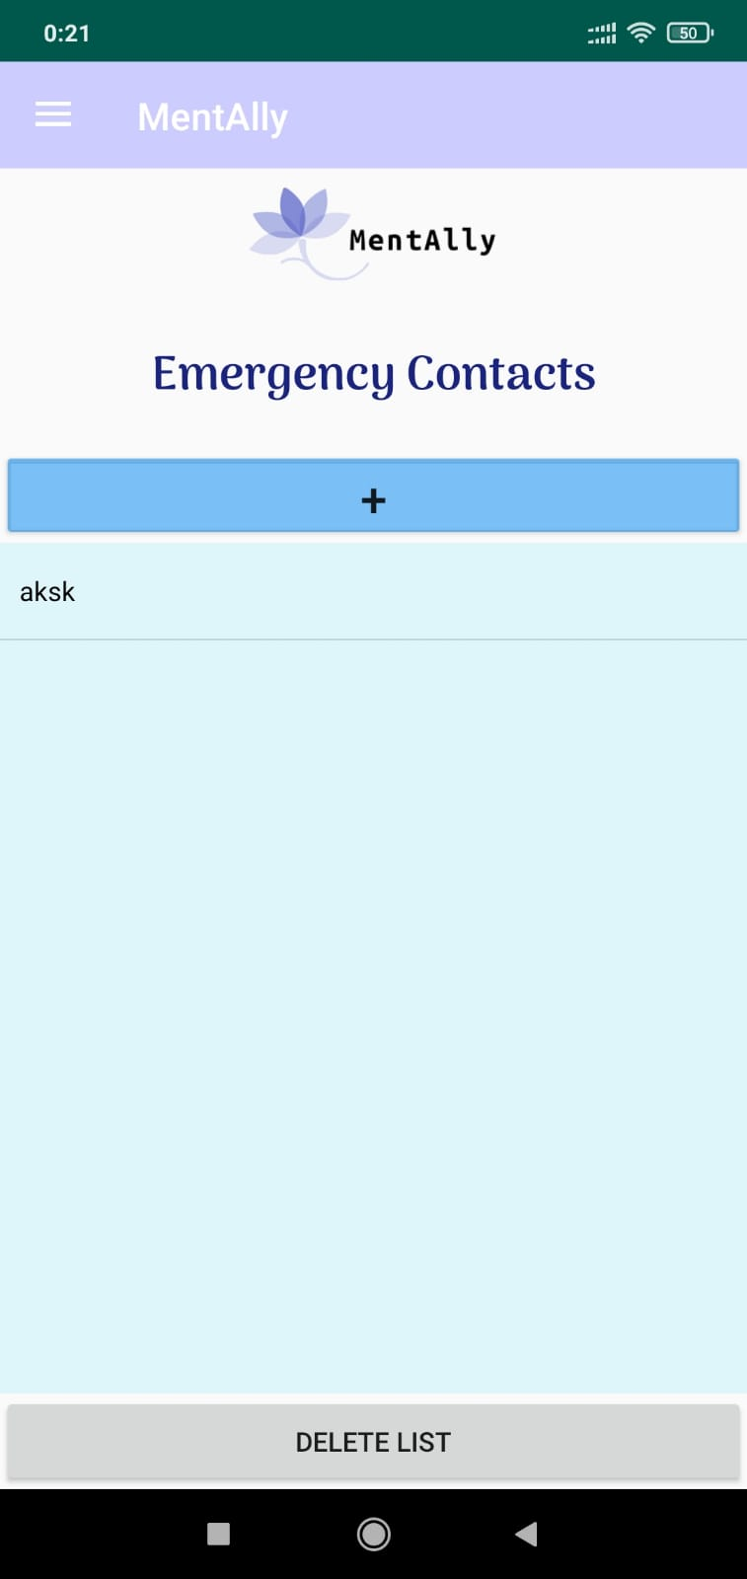

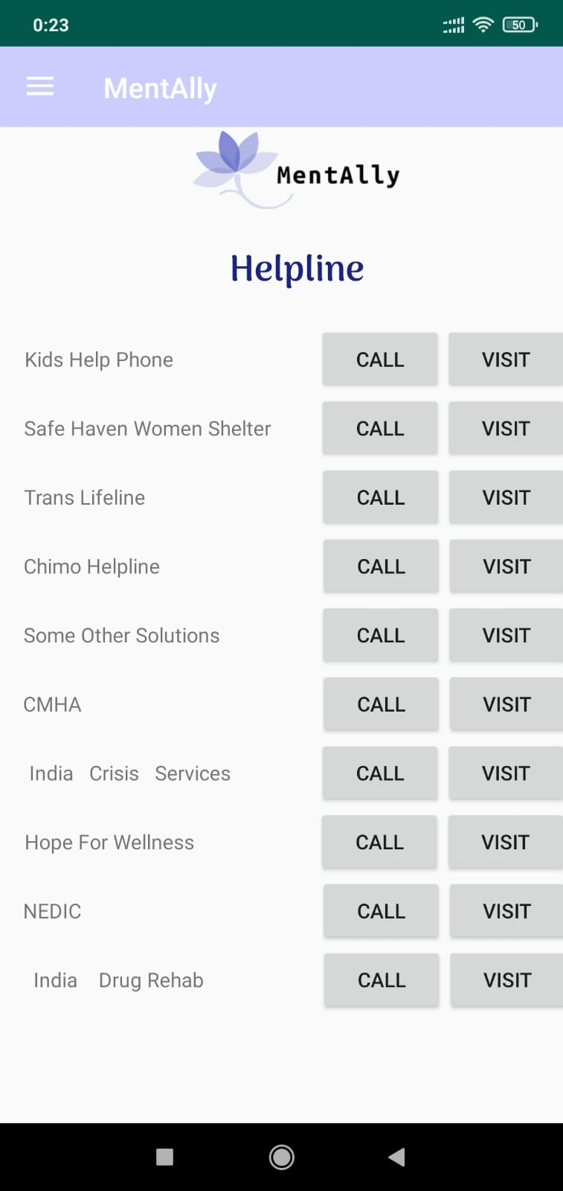

**4. Conclusion**

The results of the app on the given database were able to identify individuals with mental illness based on the information tracked by them. Habit Tracker as a feature can track the habits and keep count of them based on weekly, monthly, etc, also Emergency contacts module where users can enter family members’ contacts and contact them in an emergency.

**5. REFERENCE**

* 1. <https://www.tutorialspoint.com/index.html>
  2. [https://www.geeksforgeeks.org](https://www.geeksforgeeks.org/)
  3. <https://github.com/>
  4. <https://stackoverflow.com/>